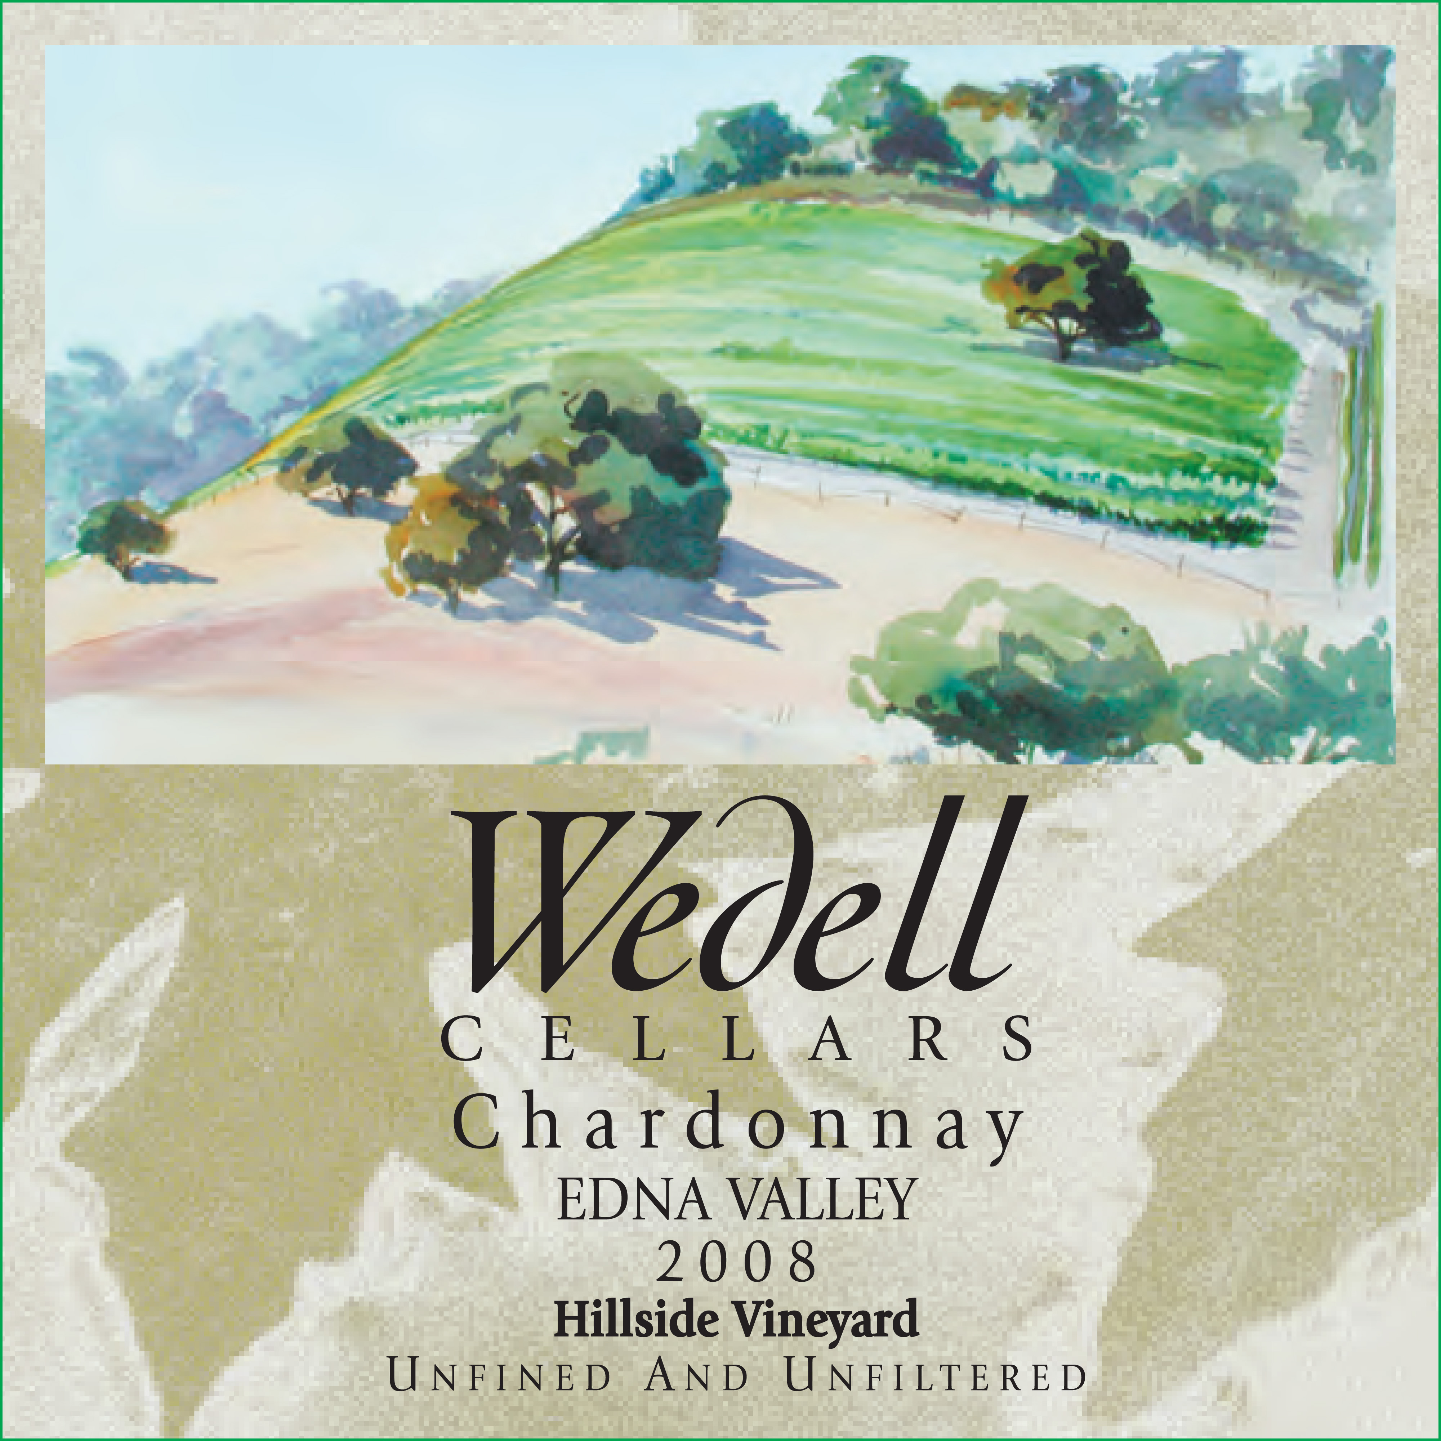


2008 Wedell Cellars “Hillside Vineyard” Chardonnay

We feel our 2008 Wedell “Hillside Vineyard” Chardonnay is really a remarkable wine from a truly special place, our Hillside Estate Vineyard. Comprising of just one acre in the midst of our Pinot Noir Vineyard, the fourteen hundred vines have consistently produced remarkable Chardonnay. The north- facing hillside has presented some very daunting challenges, indeed in 2003 and 2005 the vineyard did not even produce enough grapes to make even one barrel of wine. For 2008 the Hillside Vineyard rewarded us with just enough fruit for two barrels of wine, and once again we feel that our goals in originally planting our vineyard have been exceeded with the 2008 Wedell Cellars “Hillside Vineyard” Chardonnay.

Wedell Cellars’ philosophy has always been that “less is more”, the 2008 Wedell Cellars “Hillside Vineyard” Chardonnay exemplifies this. We intentionally kept the yield on our vineyard exceptionally low, less than twenty-three ounces per vine. Our Hillside Vineyard produced just two barrels of Chardonnay resulting in a wine that is truly Burgundian in style. As we have done in the past, we use wild indigenous yeast for fermentation. Because of the location of our vineyard (steep hillside) and its orientation (north facing), our grapes have naturally high acids. After being selectively hand harvested, the grapes were pressed whole cluster and barrel fermented for four weeks using naturally occurring wild yeasts. After the wine had fermented dry we induced malolactic fermentation to soften the acidity that took four months to complete, then the wine was aged sur lies for an additional eighteen months. Finally, in August 2010, to retain all the richness and complexity of the wine, it was racked off of its lees and bottled unfined and unfiltered.

Our 2008 Wedell Cellars ”Hillside Vineyard” Chardonnay is all about Terrior. The wine is unlike any other Chardonnay from the Edna Valley Appellation. Although it has undergone 100% malolactic fermentation there is no hint of butter and while it has been aged for a considerable amount of time in new French oak, the oak is complimentary but not overpowering. The 2008 Wedell Cellars “Hillside Vineyard” Chardonnay has an incredible rich mouth feel, immersing you in a spectacular balance of oak, fruit and acidity with a lingering complex finish. Because it is so balanced, we feel that we have created a wine that while enjoyable now will age and mature beautifully for many years to come.

TECHNICAL NOTES
Harvest Date September 26, 2008
Brix 25.7
Acid 3.22 PH, 7.5TA
Barrels Ermitage Les Bertranges French Oak 50% new
Bottled August 11, 2010
Alcohol 14.9%
Production 750ml: 504 Bottles (84 Six Pack Cases)
1.5 Liter: 24 Bottles (Hand signed, Dated & Numbered)

TEL. 805.489.0596 FAX 805.481.9708 WWW.WEDELLCELLARS.COM

